# Residual Current Devices

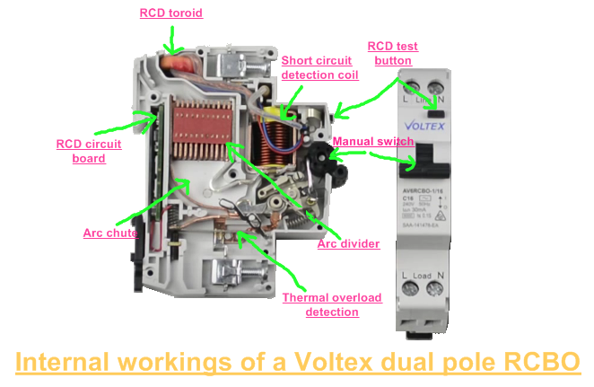The RCD is an electrical safety device specifically designed to immediately switch the electrical current flow when current leaking to earth is detected at a level harmful to a person using electrical equipment to prevent you from getting a fatal electric shock if you touch something live. It also offers a high level of personal protection from electric shock. Moreover, helps to reduce the risk of fire by detecting electrical leakage to earth in electrical wiring and accessories. RCDs offer a level of personal protection that ordinary fuses and circuit-breakers cannot provide.

## Theory of operation

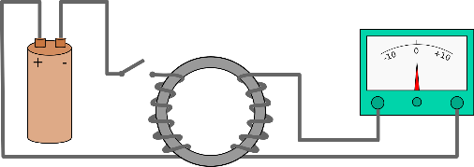It has very simple working based on [Kirchhoff’s Current Law](https://www.electrical4u.com/kirchhoff-current-law-and-kirchhoff-voltage-law/) where the incoming [current](https://www.electrical4u.com/electric-current-and-theory-of-electricity/) in a circuit must be equal to the outgoing current from that circuit. And this current is detected by Faraday’s Law of Induction which describes how an electric current produces a magnetic field and, conversely, how a changing magnetic field generates an electric current in a conductor.

Using those 2 Laws to have our device. Which use toroid core to have the wires through so the magnetic field generated in it will flow through this core. So In absence of an earth fault, the theoretical sum of the currents is equal to zero. In case of an earth fault if the currents value exceeds the rated residual operating current, the circuit at the secondary side of the toroid sends a command signal to trip coil causing the tripping of the circuit breaker. This trip may happen in two ways electromagnetic & electronic and both offer very reliable performance. 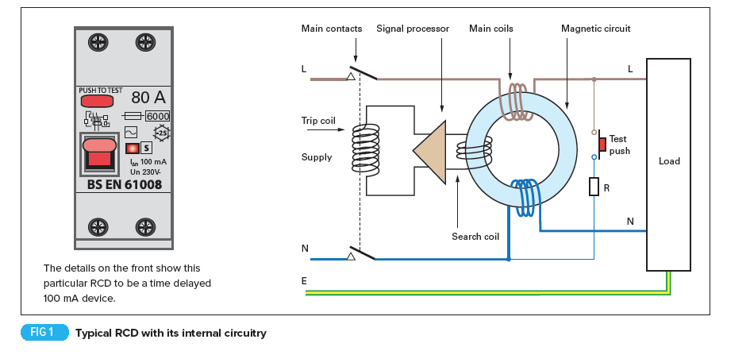Electromagnetic devices use a very sensitive toroid, which operates the trip relay when it detects very small residual currents. Electronic devices do not need such a sensitive toroid as electronic circuits within the device amplify the signal to operate the trip relay.

## Types

RCDs can help protect you from electric shock in potentially dangerous areas and there are various types of RCDs that can be used to make sure you are always as safe as possible.

### RCCB  (Residual Current Circuit Breaker)

The **RCCB** detects a current difference between the live and neutral conductors.  This current is known as a residual current. Correctly functioning circuits will always have a balanced live and neutral current and a residual current only occurs when there is a fault or potential shock hazard. The current imbalance is usually detected by directing the current path for both the live and neutral conductors to wrap around a toroidal transformer contained within the RCCB body.  The generated magnetic flux is directly proportional to the current drawn through either the live or neutral conductors. The windings are constructed so the live and neutral currents induce magnetic fields in opposite directions. The balanced magnetic fields cancel each other out, making a net zero magnetic flux within the toroid. Even a small difference in current will result in a net magnetic flux greater than zero. When the net flux is proportional to the leakage current trigger point, the unit will trip out.

### RCBO  (Residual Current Breaker with Overload)

It is a combination of a residual current device and a miniature circuit breaker in one package. When a current leakage fault occurs the internal residual current detecting element will trip the whole circuit.  Equally, if the circuit is overloaded the internal thermal or magnetic circuit breaker parts are able to trip the device in the same way.

### ELCB  (Earth Leakage Circuit Breaker)

An ELCB is similar to RCCB but have earthed connection was used to detect any voltage difference between the earth and neutral indicating that there was a current flow into the earth being monitored.

## Sensitivity

RCDs have a big range of operation. There is types can detect small leakage or fault current. Other types which are less expensive operates at higher values.

* High sensitivity: 5, 10, 30 mA (for direct-contact or life injury protection),
* Medium sensitivity: 100, 300, 500, 1000 mA (for fire protection),
* Low sensitivity: 3, 10, 30 A (typically for protection of machine).

## Limitations

RCDs will not protect against all instances of electric shock. If a person comes into contact with both the active and neutral conductors while handling faulty parts of an electrical installation causing electric current to flow through the person's body, this contact will not be detected by the RCD unless there is also a current flow to earth. The RCD will only act automatically to disconnect the electricity supply if a fault causes electric current to flow from the active conductor to earth through a person's body. That’s why RCDs can’t be used in TNC systems.

## Importance in electrical circuit

RCDs should operate within 25–40 milliseconds with any leakage currents (through a person) of greater than 30 mA, before electric shock can drive the heart into [ventricular fibrillation](https://en.wikipedia.org/wiki/Ventricular_fibrillation), (the most common cause of death through electric shock).

(Hamza 7ot el applications hena)

## Installation Types

Blah blah blah… (Hamza)

### Fixed RCDs

These are installed in the [consumer unit (fusebox)](https://www.electricalsafetyfirst.org.uk/guidance/safety-around-the-home/fuseboxes-explained/) and can provide protection to individual or groups of circuits. A fixed RCD provides the highest level of protection as it protects all the wiring and the sockets on a circuit, and any connected appliances.

### Socket-Outlet RCDs

These are special socket-outlets with an RCD built into them which can be used in place of a standard socket-outlet. This type of RCD provides protection only to the person in contact with equipment, including its lead, plugged into the special socket-outlet.

### Portable RCDs

These plug into any standard socket-outlet. An appliance can then be plugged into the RCD. They are useful when neither fixed nor socket-outlet RCDs are available but, as with socket-outlet RCDs, they provide protection only to the person in contact with the equipment, including its lead, plugged into the portable RCD.

# References

* <https://ieeexplore.ieee.org/abstract/document/1351184>
* <https://www.sciencedirect.com/topics/engineering/residual-current-device>
* <https://www.voltimum.co.uk/articles/rcds-and-18th-edition>
* <https://professional-electrician.com/18th-edition/rcds-operation-application-explained/>
* <https://www.electrical4u.com/residual-current-circuit-breaker/>
* <https://www.electricalengineeringtoolbox.com/2016/01/how-residual-current-device-rcd-works.html>